**C2P - Hire EquipmenT**

**PROJECT MANUAL**

**Cover Page**

- Title of the project

- Subtitle (if applicable)

- Names of team members

- Course information

- Institution

- Date

**GROUP TEAM MEMBERS**

**(C00288657) EMMANOEL ABOLADE**

**(C00291296) IHOR ANTONOV**

**(C00290950) IHOR Melashchenko**

**(C00288302) MARVIN A. Z. SANTOS**

**DETAILS**

[**SEM2 - Project Year 2**](https://blackboard.itcarlow.ie/webapps/blackboard/execute/courseMain?course_id=_27193_1)

**due DATE: 15TH APRIL 2024**

**PROJECT SUPERVISOR**

**TIM CASEY**

**Table of Contents**

User Interface2

Add Page2

Delete Page3

Amend/View Page4

Menu Page5

Project overview Diagram System Layout.6

database7

Customer7

Customer Payment8

Equipment Item9

Equipment Type10

Hire11

Order12

Staff13

Supplier14

Order15

Group Work.16

Menu Html16

Menu CSS17

Individual Work(Emmanoel Abolade).18

ER Diagram18

Add, Delete, Amend Equipment Type Pages20

Individual Work(Ihor antonov).23

ER Entities23

Add, Delete, Amend Pages Customer24

Individual Work(ihor Malaschencko).28

Menu Page28

Add, Delete, Amend Equipment Type Pages29

Individual Work(Marvin A. Z. Santos).33

Look and Feel33

Add, Delete, Amend Pages Supplier 34

**User Interface**

**- Add Page Description**

**Layout:** The page is divided into two sections: the left section contains submenu options, while the right section is dedicated to adding a new supplier.  
  
**Alignment:** Both sections are horizontally and vertically centered within their containers, ensuring a visually balanced layout.  
  
**Background:** The left section has a light gray background, providing a subtle contrast to the white background of the right section, enhancing readability.  
  
**Border:** Input fields in the form are bordered with a light gray border, distinguishing them from the background and providing visual clarity.  
  
**Font and Font Size:** The default browser font is used for text throughout the page, maintaining consistency and readability. Headings are slightly larger to draw attention to important sections.  
  
**Text Color:** Black text is predominantly used for content, with white text used for buttons and icons, ensuring clear visibility and contrast against the background.  
  
**Headings:** Clear and descriptive headings guide the user through the page, with the main heading prominently indicating the purpose of adding a new supplier.  
  
**Buttons:** Strategically positioned below input fields, buttons feature bold text and a cohesive blue color scheme, ensuring they stand out as actionable elements.  
  
**Other Elements:** The form incorporates labeled input fields for information, each with appropriate validation patterns to ensure data accuracy. The layout is designed to facilitate a smooth and intuitive user experience.

**User Interface**

**- Delete Page Description**

**Layout:** The page layout follows a similar structure to the Add page, with two sections: the left section contains submenu options, and the right section is dedicated to deleting a supplier.  
  
**Alignment:** Both sections are horizontally and vertically centered within their containers, ensuring a balanced and visually appealing layout.  
  
**Background:** The left section has a light gray background, providing a subtle contrast to the white background of the right section, enhancing readability and focus on the delete form.  
  
**Border:** Input fields in the form are bordered with a light gray border, distinguishing them from the background and providing visual clarity.  
  
**Font and Font Size:** Consistent with the Add page, the default browser font is used for text throughout the page, with slightly larger headings for emphasis and clarity.  
  
**Text Color:** Black text is predominantly used for content, with white text used for buttons and icons, ensuring clear visibility and contrast against the background.  
  
**Headings:** Descriptive headings guide the user through the page, with the main heading clearly indicating the purpose of deleting a supplier.  
  
**Buttons:** Buttons are strategically positioned below input fields, featuring bold text and a cohesive blue color scheme, ensuring they stand out as actionable elements.  
  
**Other Elements:** The form includes labeled input fields for information, with JavaScript functions provided for populating details and confirming deletion. The layout is designed to facilitate a smooth and intuitive user experience.

**User Interface**

**- Amend/View Page Description**

**Layout:** The layout of the page consists of two main sections: the left section containing submenu options and the right section dedicated to amending or viewing details.  
  
**Alignment:** Both sections are aligned horizontally and vertically within their containers, ensuring a balanced and visually appealing layout.  
  
**Background:** The left section has a light gray background, providing a subtle contrast to the white background of the right section, enhancing readability and focus on the form.  
  
**Border:** Input fields in the form are bordered with a light gray border, distinguishing them from the background and providing visual clarity.  
  
**Font and Font Size:** Consistent with the other pages, the default browser font is used for text throughout the page, with slightly larger headings for emphasis and clarity.  
  
**Text Color:** Black text is predominantly used for content, with white text used for buttons and icons, ensuring clear visibility and contrast against the background.  
  
**Headings:** Descriptive headings guide the user through the page, with the main heading clearly indicating the purpose of amending or viewing details.  
  
**Buttons:** Buttons are strategically positioned below input fields, featuring bold text and a cohesive blue color scheme, ensuring they stand out as actionable elements.  
  
**Other Elements:** The form includes labeled input fields for relevant information, with JavaScript functions provided for populating details, toggling input field lock, and confirming changes. The layout is designed to facilitate a smooth and intuitive user experience.

**User Interface**

**- Menu Page Description**

**Layout:** The layout of the page is centered both horizontally and vertically within the viewport, providing a balanced presentation of menu options.  
  
**Alignment:** Menu buttons are aligned vertically in the center of the page, ensuring easy readability and accessibility for users.  
  
**Background:** The background of the content area is a semi-transparent white color, creating a subtle contrast with the surrounding background while maintaining focus on the menu items.  
  
**Border:** The content area is bordered with a soft shadow effect, adding depth and dimension to the page without overwhelming the menu buttons.  
  
**Font and Font Size:** The Segoe UI font is used for text throughout the page, providing a clean and modern aesthetic. The font size is consistent, with larger headings for emphasis.  
  
**Text Color:** Black text is used for headings and button labels, ensuring clear visibility against the light background.  
  
**Headings:** The main heading "Main Menu" is prominently displayed at the top of the page, providing clear guidance to users about the purpose of the menu.  
  
**Buttons:** Menu buttons are styled with a cohesive blue color scheme, featuring bold text and a consistent width for a unified appearance. A hover effect is applied to enhance interactivity and user feedback.  
  
**Other Elements:** The page includes a "Log out" button styled differently from the menu buttons, prominently positioned at the bottom of the menu container for easy access. This button stands out with a red background color, signaling its importance as a logout action.

**System Layout**

**- Project overview Diagram**

**Database Tables**

**- Customer Structure Table**

**- Customer Populated Table**

**Database Tables**

**- Customer Payment Structure Table   
  
**

**- Customer Payment Populated Table**

**Database Tables**

**- Equipment Item Structure Table**

**- Equipment Item Populated Table**

**Database Tables**

**- Equipment Type Structure Table**

**- Equipment Type Populated Table**

**Database Tables**

**- Hire Structure Table**

**- Hire Populated Table**

**Database Tables**

**- Order Item Structure Table**

**- Order Item Populated Table**

**Database Tables**

**- Staff Structure Table**

**- Staff Populated Table**

**Database Tables**

**- Supplier Structure Table**

**- Supplier Populated Table**

**Database Tables**

**- Order Structure Table**

**- Order Populated Table**

**Group Work**

**- Html Menu Page**

**Group Work**

**- CSS Menu Page**

**Individual Work** (Emmanuel Abolade)

**- ER Diagram**

**Individual Work** (Emmanuel Abolade)

**- Add Equipment Type Page – Screenshot**

**Individual Work** (Emmanuel Abolade)

**- Add Equipment Type Page – Html – Part 1**

**Individual Work** (Emmanuel Abolade)

**- Add Equipment Type Page – Html – Part 2**

**Individual Work** (Emmanuel Abolade)

**- Delete Equipment Type Page - Screenshot**

****

**Individual Work** (Emmanuel Abolade)

**- Delete Equipment Type Page – Html Part 1**

**Individual Work** (Emmanuel Abolade)

**- Delete Equipment Type Page – Html Part 2**

**  
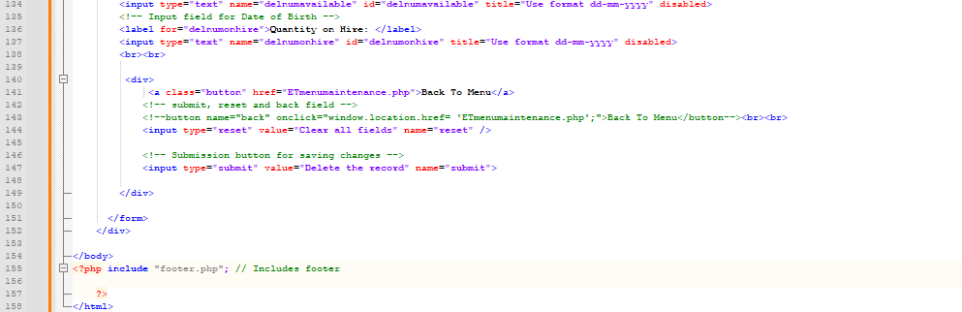**

**Individual Work** (Emmanuel Abolade)

**- Amend/View Equipment Type Page – Screenshot**

****

**Individual Work** (Emmanuel Abolade)

**- Amend/View Equipment Type Page – Html Part 1**

**Individual Work** (Emmanuel Abolade)

**- Amend/View Equipment Type Page – Html Part 2**

****

**Individual Work** (Emmanuel Abolade)

**- Hiring of Equipment Page - Screenshot**

**Individual Work** (Emmanuel Abolade)

**- Hiring of Equipment Page – Html Part 1**

**Individual Work** (Emmanuel Abolade)

**- Hiring of Equipment Page – Html Part 2**

**  
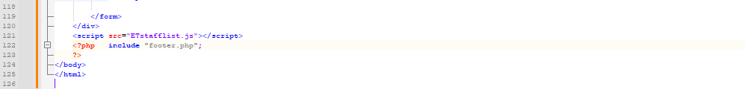**

**Individual Work** (Ihor Antonov)

**– ER Entities**

**Hire Table:** hire_id, number_of_days, duedate, cost, item_id  
  
**Equipment Item Table:** id, condition, date bought, price, type_id, hired_status, is_deleted  
  
**Equipment Type Table:** type_id, desc, brand, category, supplier_id, supplier_catalogue_code, cost_per_day, number_available, numbr_on_hire, is_deleted  
  
**Customer Table:** id, name, surname, address, eircode, phone_number, credit_limit, money_balance, is_deleted  
  
**Customer Payment Table:** id, cust_id, payment_date, details, payment_type  
  
**Order Table:** id, date, supplier_id, is_delivered, delivery_date  
  
**Order Item Table:** id, order_id, type_id, quantity  
  
**Supplier Table:** id, trading_name, address, eircode, phoneno, email, website, is_deleted  
  
**Staff Table:** id, name, surname, address, eircode, phone_number, job_title, username, password, is_deleted

**Individual Work**(Ihor Antonov)

**– Add a Customer Page – Screenshot**

**Individual Work**(Ihor Antonov)

**– Add a Customer Page – Html**

**Individual Work** (Ihor Antonov)

**– Delete a Customer Page - Screenshot**

**Individual Work** (Ihor Antonov)

**– Delete a Customer Page – Html – Part 1**

****

**Individual Work** (Ihor Antonov)

**– Amend/View Customer Page Screenshot**

**Individual Work** (Ihor Antonov)

**– Amend/View Customer Page Html**

****

**Individual Work** (Ihor Antonov)

**- Return of Equipment Page Screenshot**

**Individual Work** (Ihor Antonov)

**- Return of Equipment Page Html**

**Individual Work** (Ihor Melashchenko)

**– Menu System**

**Individual Work***(*Ihor Melashchenko)

**– Add Equipment Item**

**Individual Work***(*Ihor Melashchenko)

**– Add Equipment Item Html**

****

**Individual Work***(*Ihor Melashchenko)

**– Delete Equipment Item Screenshot**

**Individual Work***(*Ihor Melashchenko)

**– Delete Equipment Item Html**

****

**Individual Work** (Ihor Melashchenko)

**– Amend/View Equip. Item Screenshot**

**Individual Work** (Ihor Melashchenko)

**– Amend/View Equip. Item Html**

****

**Individual Work** (Marvin A. Z. Santos)

**– Look & Feel Research**

Layout and Alignment, Background and Border, Font and Font Size, Text Colour, Heading, Button and Element Positioning.

**- Color Scheme**

**Primary:** #004E98 (Blue) - Represents trust and professionalism.

**Secondary:** #3A6EA5 (Light Blue) - Indicates success and positive actions.

**Tertiary:** #C0C0C0 (Gray) - Provides balance and readability.

**Background:** #EBEBEB (Light Gray) - Enhances readability and visual comfort.

**Accent:** #FF6700 (Orange) - Draws attention to important alerts and notifications.

**Individual Work** (Marvin A. Z. Santos)

**Add a Supplier - Screenshot**

**Add a Supplier - Html**

**Individual Work**(Marvin A. Z. Santos)

**Delete a Supplier - Screenshot**

**Individual Work**(Marvin A. Z. Santos)

**Delete a Supplier – Html - Part 1**

**Individual Work**(Marvin A. Z. Santos)

**Delete a Supplier – Html - Part 2**

****

**Individual Work**(Marvin A. Z. Santos)

**Amend/View a Supplier – Screenshot**

**Individual Work**(Marvin A. Z. Santos)

**Amend/View a Supplier – Html Part 1**

**Individual Work**(Marvin A. Z. Santos)

**Amend/View a Supplier – Html Part 2**

****

**Individual Work** (Marvin A. Z. Santos)

**Make a Payment - Screenshot**

**Individual Work** (Marvin A. Z. Santos)

**Make a Payment – Html – Part 1**

**Individual Work** (Marvin A. Z. Santos)

**Make a Payment – Html – Part 2**

****